**PIZZA SQL QUERIES**

1. **KPIs**
2. **Total Revenue:**

select sum(total_price) as Total_Revenue from pizza_sales;

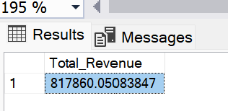

1. **Average Order Value**

select sum(total_price) / count(distinct(order_id)) as Average_Order_Value from pizza_sales;

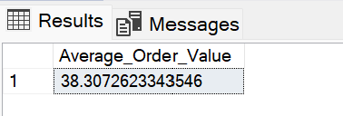

1. **Total Pizzas Sold**

select sum(quantity) as Total_Pizza_Sold from pizza_sales;

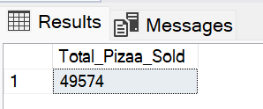

1. **Total Orders Placed**

select count(distinct(order_id)) as Total_Orders from pizza_sales;

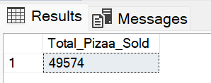

1. **Average Pizzas Per Order**

select cast(cast(sum(quantity) as decimal(10,2))/ cast(count(distinct order_id) as decimal(10,2)) as decimal(10,2)) as Avg_Pizzas_Per_Order from pizza_sales;

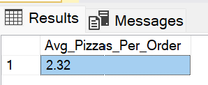

1. **Daily Trend For Total Orders**

select datename(dw,order_date) as Order_Day, count(distinct order_id) as Total_orders from pizza_sales group by datename(dw, order_date);

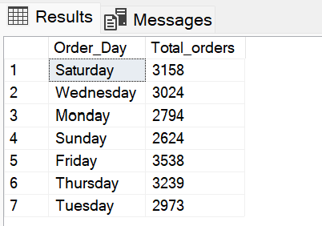

1. **Monthly Trend For Orders**

select datename(month, order_date) as Month_Name, count(distinct order_id) as Total_Orders from pizza_sales group by datename(month, order_date) order by Total_Orders DESC;

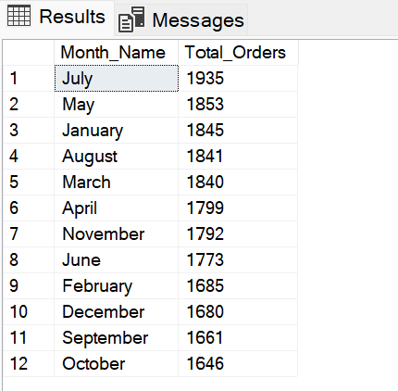

1. **Percentage of Sales by Pizza Category**

select pizza_category, cast(sum(total_price) as decimal(10,2)) as Total_Revenue, cast(sum(total_price)*100/(select sum(total_price) from pizza_sales) as decimal(10,2)) as PCT_Sales_per_category from pizza_sales group by pizza_category;

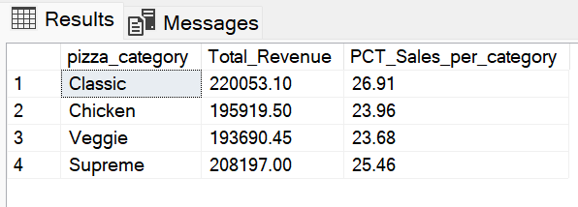

1. **Percentage of Sales By Pizza Size**

select pizza_size, cast(sum(total_price) as decimal(10,2)) as Total_Revenue, cast(sum(total_price)*100/(select sum(total_price) from pizza_sales) as decimal(10,2)) as PCT_Sales_per_category from pizza_sales group by pizza_size;

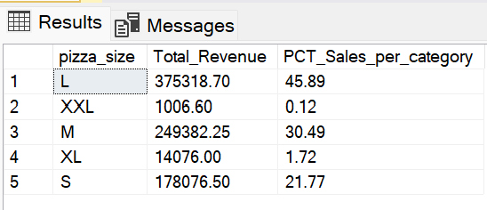

1. **Total Pizzas Sold By Pizza Category**

select pizza_category, sum(quantity) as Total_Quantity_Sold from pizza_sales group by pizza_category order by Total_Quantity_Sold desc;

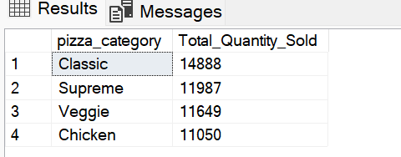

1. **Top/Bottom 5 Pizzas By Revenue**

**Top 5:**

select top 5 pizza_name, sum(total_price) as Total_Revenue from pizza_sales group by pizza_name order by Total_Revenue desc

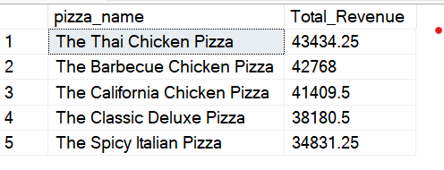

**Bottom 5:**

select top 5 pizza_name, sum(total_price) as Total_Revenue from pizza_sales group by pizza_name order by Total_Revenue asc

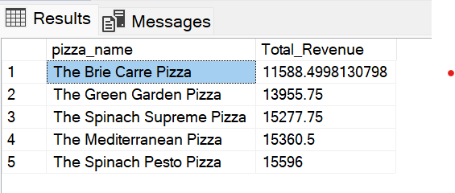

1. **Top/Bottom 5 Pizzas By Quantity**

**Top 5:**

select top 5 pizza_name, sum(quantity) as Total_Quantity from pizza_sales group by pizza_name order by Total_Quantity desc;

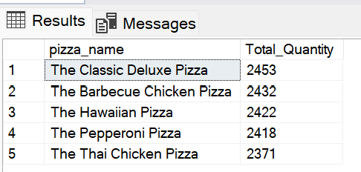  
**Bottom 5:**

select top 5 pizza_name, sum(quantity) as Total_Quantity from pizza_sales group by pizza_name order by Total_Quantity asc;

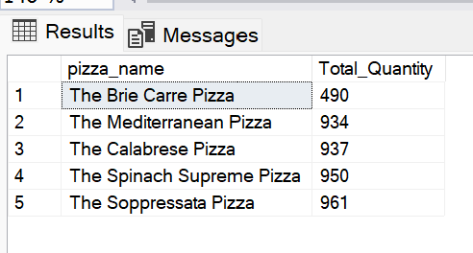

1. **Top/Bottom 5 Pizzas By Orders**

**Top 5:**

select top 5 pizza_name, count(distinct order_id) as Total_Orders from pizza_sales group by pizza_name order by Total_Orders desc;

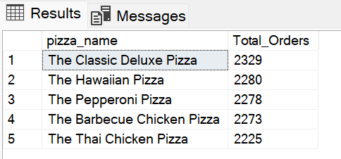

**Bottom 5:**

select top 5 pizza_name, count(distinct order_id) as Total_Orders from pizza_sales group by pizza_name order by Total_Orders asc;

